Project Design Phase II Technology Stack(Architecture & Stack)

|  |  |
| --- | --- |
| Date | 16 October 2022 |
| Team Id | PNT2022TMID33581 |
| Project Name | AI-powered nutrition analyzer  for fitness enthusiasts |
| Marks | 4marks |

Data Processing User

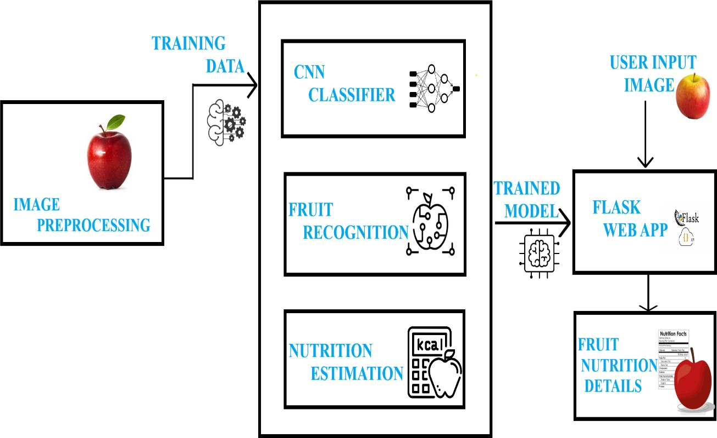

Table-1: Components & Technologies

|  |  |  |  |
| --- | --- | --- | --- |
| **S.No** | **Component** | **Description** | **Technology** |
| 1. | User Interface | How user interacts with application for predicting the nutrition | HTML,CSS,Javascript |
| 2. | Application Logic-1 | Logic for a process in the application | Python |
| 3. | Application Logic -2 | Logic for a process in the application | IBM Watson STT service |
| 4. | Application Logic -3 | Logic for a process in the application | IBM Watson Assistant |
| 5. | Database | Data Type, Configurations etc. | MySQI,NoSQL |
| 6. | Cloud Database | Database Service on Cloud | IBM DB2,IBM  Cloudant et |
| 7. | File Storage | File storage requirements | IBM Block Storage or Other Storage Service or Local  Filesystem |
| 8. | External API-1 | Purpose of External API used in the application | IBM Weather API, etc. |
| 9. | External API-2 | Purpose of External API used in the application | Aadhar API |
| 10. | Machine Learning  Model | Purpose of Machine Learning Model | OpenCV,MATLAB |
| 11. | Infrastructure (server/cloud) | Application Deployment on Local System / Cloud  Local Server Configuration: Cloud Server Configuration | Local, Cloud Foundry, Kubernetes, etc. |

Table-2: Application Characteristics:

|  |  |  |  |
| --- | --- | --- | --- |
| **S.No** | **Characteristics** | **Description** | **Technology** |
| 1. | Open-Source Frameworks | The open-source frameworks used | SendGrid,python,jQuery |
| 2. | Security Implementations | All the security / access controls implemented,  use of firewalls etc. | Encryption,SSL certs |
| 3. | Scalable Architecture | The scalability of architecture (3 – tier, Micro-services) | Web Server – HTML, CSS, JavaScript Application Server  – Python Flask Database Server – IBM Cloud |
| 4. | Availability | Availability of application (e.g. use of load balancers, distributed  servers etc.) | IBM Cloud hosting |
| 5. | Performance | Design consideration for the performance of the application (number of requests per sec, use of Cache, use of CDN’s)  etc. | IBM Load Balance |